France Information Sheet:
Name:
Date:

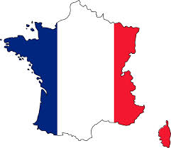

Aim: to complete the following fact file on France:

Colour of the Flag:

Capital City:

Currency:

Population:

Five Biggest Cities:

Surrounding Countries:

Famous Composer from France:

Famous Artist from France:

Current President of France:

Famous Landmarks:

Highest Mountain:

Longest River:

Popular foods:

